1. Write a blog on Difference between HTTP1.1 vs HTTP2
2. Write a blog about objects and its internal representation in Javascript

 HTTP/1.1 loads resources one after the other, so if one resource cannot be loaded, it blocks all the other resources behind it. In contrast, HTTP/2 is able to use a single TCP connection to send multiple streams of data at once so that no one resource blocks any other resource.

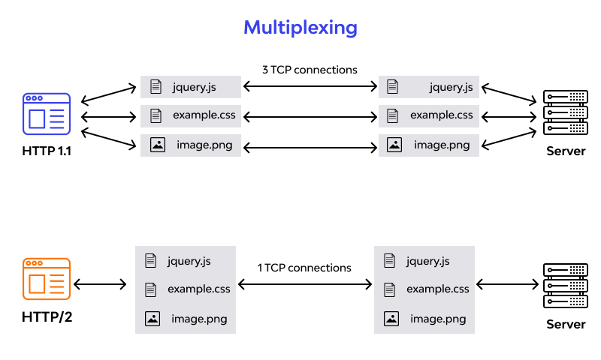

Objects, in JavaScript, is it’s most important data-type and forms the building blocks for modern JavaScript. These objects are quite different from JavaScript’s primitive data-types(Number, String, Boolean, null, undefined and symbol) in the sense that while these primitive data-types all store a single value each (depending on their types).

Objects are more complex and each object may contain any combination of these primitive data-types as well as reference data-types.  
An object, is a reference data type. Variables that are assigned a reference value are given a reference or a pointer to that value. That reference or pointer points to the location in memory where the object is stored. The variables don’t actually store the value.

Loosely speaking, objects in JavaScript may be defined as an unordered collection of related data, of primitive or reference types, in the form of “key: value” pairs. These keys can be variables or functions and are called properties and methods, respectively, in the context of an object.

For Eg. If your object is a student, it will have properties like name, age, address, id, etc and methods like updateAddress, updateNam, etc.

**Objects and properties**

A JavaScript object has properties associated with it. A property of an object can be explained as a variable that is attached to the object. Object properties are basically the same as ordinary JavaScript variables, except for the attachment to objects. The properties of an object define the characteristics of the object. You access the properties of an object with a simple dot-notation:

objectName.propertyName

Like all JavaScript variables, both the object name (which could be a normal variable) and property name are case sensitive. You can define a property by assigning it a value. For example, let’s create an object named myCar and give it properties named make, model, and year as follows:

var myCar = new Object();  
myCar.make = 'Ford';  
myCar.model = 'Mustang';  
myCar.year = 1969;

Unassigned properties of an object are [undefined](https://developer.mozilla.org/en-US/docs/Web/JavaScript/Reference/Global_Objects/undefined) (and not [null](https://developer.mozilla.org/en-US/docs/Web/JavaScript/Reference/Global_Objects/null)).